Templeogue Synge Street Gaelic Football Club Database Report

[miblack@tcd.ie|](mailto:miblack@tcd.ie|) 17341914

Application Description

The database I have designed describes some of the data required by (my club) Templeogue Synge Street Gaelic Football Club. The data describes the general operations about the clubs and can be divided into 6 entities: Team, Player, Manager, Equipment, Grounds and Match. An entity has a number of correlating attributes. For the sake of clarity, I have kept these attributes to as few as possible.

The Match entity is central to the operation of a football club. As crowd size and team size may be dictated by how well advertised the match is. Therefor the main attributes of a generic match are the Match_ID Opposition, Throw_In, Date and Venue.

The Clubhouse_Rooms table describes noteworthy data about rooms namely: Name, Type, Pin_Code

A club can be made up of many teams, each distinguishable by either their age or in the adult leagues, their division. Its attributes are: Name, Captain, Division.

The fundamental building blocks of teams and moreover clubs are the players. They contain the attributes: Registration number, Name, Address, Telephone number and Team.

The manager entity has the attributes: Name, Email Address, Telephone Number.

Finally, the equipment entity allows insight into where club equipment is stored and keeps a log of what managers use them. Set_ID, Name and Set_Size are its attributes.

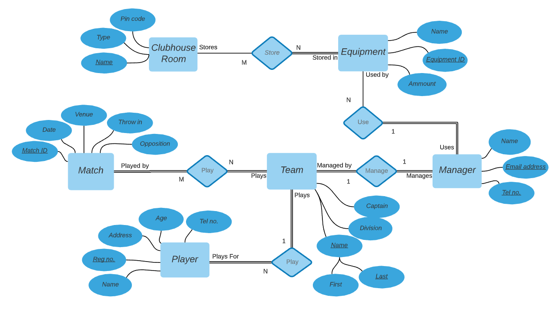Entity Relationship Diagram

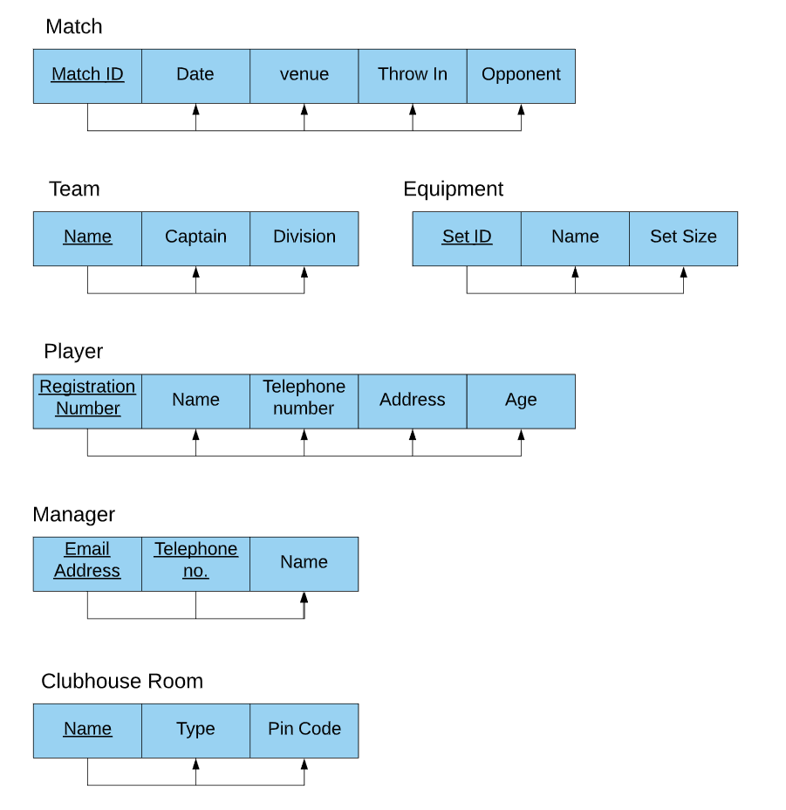Functional Dependency Diagram

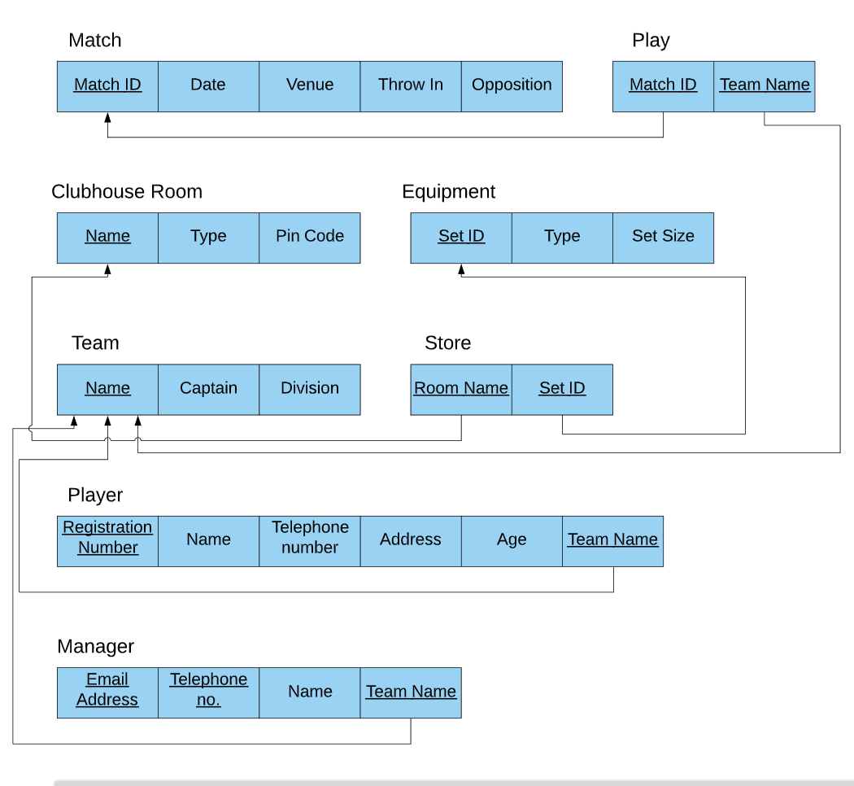Relational Schema

Normalization

Two independent additions of tables with composite primary keys that models the many to many relationships. This removes duplication were necessary.

Semantic Constraints

A NULL/NOT NULL constraint was added to every attribute during table creation. This specifies whether a value must be given to this attribute. NULL specifies the allowance of blank entries into the attribute were not applicable to the data.

Example Pin_Code CHAR(4) NULL

Either 4 digit pin codes (as a string) or NULL values are accepted with this command. That command is an extract from the creation of the table Clubhouse_Room in which only some of the rooms have locks.

Primary and Foreign keys have been declared and implemented where necessary. The Primary key specifies the unique identifier attribute within the table and the foreign key is the column that references a column from another table, and this ensures referential integrity.

One Checks constraint implemented was one which ensured registration numbers were the correct number of digits. When filling in exhaustively filling in databases any safety net such as this number checker is appreciated.

CONSTRAINT Registration_No CHECK (Registration_No >= 100000);

An additional Checks constraint was put on the store room attribute witch ensured only a valid room could be entered for the chosen equipment (‘Store_Room 1/2')

CONSTRAINT Store_Room CHECK (Store_Room == ‘Store Room 1’ OR Store_Room == ‘Store Room 2’);

These constraints were added to the bottom of their appropriate create table, however they can be used in combination with an alter statement to make constraints after the table has been created. i.e.

ALTER TABLE Store

ADD CONSTRAINT Store_Room CHECK (Store_Room == 1 OR Store_Room == 2);

Security

The restrictions put on this database are done so by means of user accounts and privileges. There is a Database Administrator (DBA) who in is charge of accounts and granting and revoking privileges. The Templeogue Synge Street DBA must create roles and assign individuals to them thereafter.

CREATE ROLE Managers;

CREATE USER GerSmith

GRANT Manager TO GerSmith;

Managers are trusted members of the club and therefore have access to the clubhouse room table as well as the equipment and player restricted tables. They may also grant read privileges to their management team so there is no need for the GRANT OPTION statement.

GRANT SELECT ON Player_Restricted TO Managers;

GRANT SELECT ON Clubhouse_Room TO Managers;

GRANT SELECT ON Equipment TO Managers;

If manager retires from his position the privileges can be updated accordingly.

ALTER ROLE Managers DROP MEMBER GerSmith;

View Creation

**Player Restricted**

CREATE VIEW Player_Restricted AS SELECT Registration_No, FName, LName, Age, Team_Name FROM Player;

This view allows access to specific non-private attributes on the players. Attributes left out were: Address and Telephone_No. As mentioned earlier, only those granted higher read privilege are allowed access to this information.

**Manager_Restricted**

CREATE VIEW Manager_Restricted AS SELECT FName, LName, Team_Name FROM Manager;

Identical logic to the player restricted view. Not implemented in the database but done to show its use.

Triggers

In football, unforeseen events may cause a team to be disbanded. A huge amount of co-operation is needed for this sport because every role is voluntary. An untimely round of injuries may be enough to fall below the eligible players limit and would cause a manager to withdraw his team from the league. Basically, its common. So, let us account for this by means of triggers. A trigger is a stored procedure in database which automatically invokes whenever a special event in a database occurs.

Its easy to remember the most obvious deletion after removing a Team, you delete manager and remove the upcoming fixtures from the league. However, it is just as important to update the more subtle entities to preserve a functional database. Such subtleties include removing the team name from the player records. The following trigger does this.

CREATE DEFINER=`root`@`localhost` TRIGGER `team_BEFORE_DELETE` BEFORE DELETE ON `team` FOR EACH ROW

BEGIN

UPDATE Player SET Player.Team_Name = NULL

WHERE Player.Team_Name = Old.Name;

END

Appendix

CREATE TABLE Match_ ( Match_ID INTEGER NOT NULL,

Date DATE NOT NULL,

Opponent VARCHAR(30) NOT NULL,

Venue VARCHAR(20) NOT NULL,

Throw_In TIME(0) NOT NULL,

PRIMARY KEY (Match_ID));

INSERT INTO Match_ VALUES(100000, '2020-01-17', 'O’Dwyers', 'Bremore Park', '11:00:00');

INSERT INTO Match_ VALUES(100022, '2020-02-6', 'Thomas Davis 2', 'Kiltipper Road', '12:00:00');

INSERT INTO Match_ VALUES(100028, '2020-02-21', 'Erins Isle', 'Finglas', '19:30:00');

INSERT INTO Match_ VALUES(100102, '2020-02-29', 'Round Towers C', 'Monastery Road', '12:00:00');

INSERT INTO Match_ VALUES(100182, '2020-03-02', 'St Brigids', 'Russel Park', '12:00:00');

INSERT INTO Match_ VALUES(100200, '2020-03-11', 'Thomas Davis 1', 'Kiltipper Road', '20:00:00');

INSERT INTO Match_ VALUES(100202, '2020-03-17', 'Croabh Chiarain', 'Clonshaugh', '11:00:00');

INSERT INTO Match_ VALUES(100254, '2020-03-02', 'Na Gael Oga', 'St Catherines Park', '19:30:00');

INSERT INTO Match_ VALUES(100265, '2020-03-11', 'St Maurs', 'Rush', '19:30:00');

INSERT INTO Match_ VALUES(100284, '2020-03-17', 'Kilmacud Crokes', 'Silver Park', '11:00:00');

CREATE TABLE Equipment ( Set_ID INTEGER NOT NULL,

Type VARCHAR(20) NOT NULL,

Set_Size INTEGER NOT NULL,

PRIMARY KEY (Set_ID));

INSERT INTO Equipment VALUES(123, 'Cones', 20);

INSERT INTO Equipment VALUES(124, 'Cones', 20);

INSERT INTO Equipment VALUES(125, 'Cones', 50);

INSERT INTO Equipment VALUES(223, 'Poles', 20);

INSERT INTO Equipment VALUES(243, 'Poles', 20);

INSERT INTO Equipment VALUES(254, 'Bibs', 50);

INSERT INTO Equipment VALUES(273, 'Balls', 20);

INSERT INTO Equipment VALUES(274, 'Balls', 20);

INSERT INTO Equipment VALUES(303, 'Ladders', 3);

CREATE TABLE Clubhouse_Room (Name VARCHAR(20) NOT NULL,

Type VARCHAR(30) NOT NULL,

Pin_Code CHAR(4) NULL,

PRIMARY KEY (Name));

INSERT INTO Clubhouse_Room VALUES('Entrance', 'Clubhouse', '7683');

INSERT INTO Clubhouse_Room VALUES('Home 1', 'Dressing Room', '4734');

INSERT INTO Clubhouse_Room VALUES('Home 2', 'Dressing Room', '2848');

INSERT INTO Clubhouse_Room VALUES('Home 3', 'Dressing Room', '8462');

INSERT INTO Clubhouse_Room VALUES('Away 1', 'Dressing Room', '2389');

INSERT INTO Clubhouse_Room VALUES('Away 2', 'Dressing Room', '9364');

INSERT INTO Clubhouse_Room VALUES('Away 3', 'Dressing Room', '8293');

INSERT INTO Clubhouse_Room VALUES('Toilet', 'Hygiene', null);

INSERT INTO Clubhouse_Room VALUES('Showers', 'Hygiene', null);

INSERT INTO Clubhouse_Room VALUES('Store_Room 1', 'Storage', '1234');

INSERT INTO Clubhouse_Room VALUES('Store_Room 2', 'Storage', '2341');

CREATE TABLE Store ( Set_ID INTEGER NOT NULL,

Store_Room VARCHAR(20) NOT NULL,

PRIMARY KEY (Set_ID, Store_Room),

FOREIGN KEY (Set_ID) REFERENCES Equipment(Set_ID),

FOREIGN KEY (Store_Room) REFERENCES Clubhouse_Room(Name),

CONSTRAINT chk_valid CHECK (Store_Room="Store_Room 1" OR Store_Room="Store_Room 2"));

INSERT INTO Store VALUES(123, 'Store_Room 1');

INSERT INTO Store VALUES(124, 'Store_Room 1');

INSERT INTO Store VALUES(125, 'Store_Room 1');

INSERT INTO Store VALUES(223, 'Store_Room 1');

INSERT INTO Store VALUES(243, 'Store_Room 1');

INSERT INTO Store VALUES(254, 'Store_Room 2');

INSERT INTO Store VALUES(273, 'Store_Room 2');

INSERT INTO Store VALUES(274, 'Store_Room 2');

INSERT INTO Store VALUES(303, 'Store_Room 2');

CREATE TABLE Team ( Name VARCHAR(50) NOT NULL,

Captain VARCHAR(20) NOT NULL,

Division INTEGER NOT NULL,

PRIMARY KEY (Name));

INSERT INTO Team VALUES('TSS Seniors', 'T. Alan', 1);

INSERT INTO Team VALUES('TSS Inters', 'G. Alan', 3);

INSERT INTO Team VALUES('TSS Junior A', 'B. Howard',5);

INSERT INTO Team VALUES('TSS Junior B', 'T. Baker', 7);

INSERT INTO Team VALUES('TSS Junior C', 'D. Murphy', 9);

CREATE TABLE Play ( Match_ID INTEGER NOT NULL,

Team_Name VARCHAR(20) NOT NULL,

PRIMARY KEY (Match_ID, Team_Name),

FOREIGN KEY (Match_ID) REFERENCES Match_(Match_ID),

FOREIGN KEY (Team_Name) REFERENCES Team(Name));

INSERT INTO Play VALUES(100000, 'TSS Seniors');

INSERT INTO Play VALUES(100022, 'TSS Junior C');

INSERT INTO Play VALUES(100028, 'TSS Seniors');

INSERT INTO Play VALUES(100102, 'TSS Inters');

INSERT INTO Play VALUES(100182, 'TSS Junior B');

INSERT INTO Play VALUES(100200, 'TSS Inters');

INSERT INTO Play VALUES(100202, 'TSS Junior C');

INSERT INTO Play VALUES(100254, 'TSS Junior A');

INSERT INTO Play VALUES(100265, 'TSS Junior A');

INSERT INTO Play VALUES(100284, 'TSS Junior B');

CREATE TABLE Player ( Registration_No INTEGER NOT NULL,

FName VARCHAR(20) NOT NULL,

LName VARCHAR(20) NOT NULL,

Age INTEGER NOT NULL,

Telephone_No INTEGER NOT NULL,

Address VARCHAR(30) NOT NULL,

Team_Name VARCHAR(20) NOT NULL,

PRIMARY KEY (Registration_No),

FOREIGN KEY (Team_Name) REFERENCES Team(Name),

CONSTRAINT Registration_No CHECK (Registration_No >= 100000));

INSERT INTO Player VALUES(100034, 'Tom', 'Alan', 25, 0841233456, '12 Main Street', 'TSS Seniors');

INSERT INTO Player VALUES(102344, 'James', 'Lynch', 32, 0823333456, '34 Orwell Lane', 'TSS Inters');

INSERT INTO Player VALUES(100788, 'Mick', 'Doherty', 26, 0871233454, '2 Lower Key', 'TSS Inters');

INSERT INTO Player VALUES(102654, 'Seamus', 'Smith', 21, 0891233455, '32 Fork Road', 'TSS Seniors');

INSERT INTO Player VALUES(102334, 'Kevin', 'Keogh', 35, 088233456, '12 Orwell Park', 'TSS Junior B');

INSERT INTO Player VALUES(109777, 'Sam', 'Baker', 39, 0861233456, '15 Kimmage Rd', 'TSS Junior A');

INSERT INTO Player VALUES(108876, 'Conor', 'Quinn', 19, 0857676556, '6 Long Road', 'TSS Inters');

INSERT INTO Player VALUES(100990, 'Jack', 'Murphy', 24, 0841233777, '1 New Park', 'TSS Seniors');

INSERT INTO Player VALUES(103542, 'Alex', 'Hughes', 26, 0841233336, '12 Mile View', 'TSS Junior C');

INSERT INTO Player VALUES(108931, 'Aaron', 'Foley', 37, 0841239996, '10 Spoon Rd', 'TSS Junior B');

CREATE TABLE Manager ( Email_Address VARCHAR(30) NOT NULL,

Telephone_No INTEGER NOT NULL,

FName VARCHAR(20) NOT NULL,

LName VARCHAR(20) NOT NULL,

Team_Name VARCHAR(20) NOT NULL,

PRIMARY KEY (Email_Address, Telephone_No),

FOREIGN KEY (Team_Name) REFERENCES Team(Name));

INSERT INTO Manager VALUES('ger123@gmail.com', 0876673425, 'Ger', 'Smith', 'TSS Seniors');

INSERT INTO Manager VALUES('bren123@gmail.com', 0854347767, 'Mike', 'Brennen', 'TSS Inters');

INSERT INTO Manager VALUES('jsmith3@gmail.com', 0833434543, 'Jack', 'Smith', 'TSS Junior A');

INSERT INTO Manager VALUES('goffer98@gmail.com', 0893899261, 'Peter', 'Goff', 'TSS Junior B');

INSERT INTO Manager VALUES('doug@gmail.com', 0876673425, 'Alan', 'Douglas', 'TSS Junior C');

CREATE ROLE Managers;

CREATE USER GerSmith, MikeBrennen, JackSmith, PeterGoff, AlanDouglas;

GRANT Managers TO GerSmith, MikeBrennen, JackSmith, PeterGoff, AlanDouglas;

GRANT SELECT ON Player_Restricted TO Managers;

GRANT SELECT ON Clubhouse_Room TO Managers;

GRANT SELECT ON Equipment TO Managers;

CREATE VIEW Player_Restricted AS SELECT Registration_No, FName, LName, Age, Team_Name FROM Player;

CREATE VIEW Manager_Restricted AS SELECT FName, LName, Team_Name FROM Manager;

CREATE DEFINER=`root`@`localhost` TRIGGER `team_BEFORE_DELETE` BEFORE DELETE ON `team` FOR EACH ROW

BEGIN

UPDATE Player SET Player.Team_Name = NULL

WHERE Player.Team_Name = Old.Name;

END